LABORATORY MANUAL
NETWORKS LAB
II B.TECH -I Semester (EEE)

AY-2018-2019
Prepared by

Lab In-charge: Mrs. A. KALPANA



CERTIFICATE

This is to certify that this manual is a bonafide record of practical work in the Network Theory Laboratory in First Semester of second year B.Tech (ECE) programme during the academic year 2018-19. The book is prepared by A. Kalpana Assistant Professor, Department of Electrical and Electronics Engineering.

Signature of HOD Signature of Director Signature of Principal

PREFACE

This book “Network Theory” lab manual is intended to teach the design and analysis of basic network theorems and their application in power systems. Readers of this book need only be familiar with the basic network theorems. The manual contains the theorems and their verification in practical to understand how calculate voltage across or current through the element in circuit. We hope that this practical manual will be helpful for students of Electrical Engineering for understanding the subject from the point of view of applied aspects. There is always scope for improvement in the manual. We would appreciate to receive valuable suggestions from readers and users for future use.

By,

A. Kalpana.

Department of Electrical & Electronics Engineering

II YEAR. B.Tech. EEE- I SEM L /T /P/C 0 /0/3/ 2
(EE307ES) NETWORKS LAB

The following experiments are required to be conducted as compulsory experiments

Verification of Thevenin’s and Norton’s Theorems
Verification of Superposition, Reciprocity and Maximum Power Transfer theorems
3. Locus Diagrams of RL and RC Series Circuits
4. Series and Parallel Resonance
5. Time response of first order RC / RL network for periodic non –sinusoidal inputs –Time constant and Steady state error determination.
6. Two port network parameters –Z –Y parameters, Analytical verification.
7. Two port network parameters –A, B, C, D & Hybrid parameters, Analytical verification
8. Separation of Self and Mutual inductance in a Coupled Circuit. Determination of Co-efficient of Coupling.
In addition to the above eight experiments, at least any two of the experiments from the following list
9. Verification of compensation &Milliman’s theorems
10. Measurement of Active Power for Star and Delta connected balanced loads.
11. Measurement of Reactive Power for Star and Delta connected balanced loads.

ACKNOWLEDGEMENT

It was really a good experience, working with Network Theory lab. First we would like to thank Mr.Abdul Nabi, Assoc.Professor, Department of Electrical and Electronics Engineering, Marri Laxman Reddy Institute of technology & Management for his concern and giving the technical support in preparing the document.
We are deeply indebted and gratefully acknowledge the constant support and valuable patronage of Dr.R.Kotaih, Director, Marri Laxman Reddy Institute of technology & Management for giving us this wonderful opportunity for preparing the Network Theory laboratory manual.
We express our hearty thanks to Dr. K. Venkateswara Reddy, Principal, Marri Laxman Reddy Institute of technology & Management, for timely corrections and scholarly guidance.
At last, but not the least I would like to thanks the entire EEE Department faculties those who had inspired and helped us to achieve our goal.

By,

A. Kalpana.

Instructions to the students to conduct an experiment:

- Students are supposed to come to the lab with preparation, proper dress code and the set of tools required (1. Cutter, 2. Tester (small size), 3. Plier (6-Inches)).

- Dress code:

Boys: Shoe & Tuck. Girls: Apron & Cut shoe.
- Don’t switch on the power supply without getting your circuit connections verified.

- Disciplinary action can be taken in the event of mishandling the equipment or switching on the power supply without faculty presence.

- All the apparatus taken should be returned to the Lab Assistant concerned, before leaving the lab.

- You have to get both your Observation book and your Record for a particular experiment corrected well before coming to the next experiment.

Guidelines to write your Observation book:

- Experiment title, Aim, Apparatus, Procedure should be right side.

- Circuit diagrams, Model graphs, Observations table, Calculations table should be left side.

- Theoretical and model calculations can be any side as per convenience.

- Result should always be at the end (i.e. there should be nothing written related to an experiment after its result).

- You have to write the information for all the experiments in your observation book.

- You are advised to leave sufficient no of pages between successive experiments in your observation book for the purpose of theoretical and model calculations.

Expt No: 1
Experimental Verification of Thevenin’s & Norton’s theorems

Aim: To verify Thevenin’s and Norton’s theorems theoretically and practically.

Apparatus:

S.No | Name of the equipment | Range | Type | Quantity
1. | Ammeter | (0-200)mAmp | Digital | 1
2. | Voltmeter | (0-20)V | Digital | 1
3. | DC Power Supply | (0-30)V | Dual | 1
4. | Digital Multimeter | ------- | Digital | 2
5. | Connecting wires | ------- | ----- | as per need

Theory:

Statement of Thevenin’s Theorem:

Any two terminal linear bilateral network containing of energy sources and impedances can be replaced with an equivalent circuit consisting of voltage source V_{th} in series with an impedance, Z_{th.}, where V_{th} is the open circuit voltage between the load terminals and Z_{th} is the equivalent impedance measured between the two terminals with all the energy sources replaced by their internal impedances.

Statement of Norton’s Theorem:

Any two terminal linear bilateral network containing of energy sources and impedances can be replaced with an equivalent circuit consisting of a Current source I_{N} in parallel with an impedance, Z_{N.}, where I_{N} is the short circuit current across the load terminals and Z_{N} is the equivalent impedance measured between the two terminals with all the energy sources replaced by their internal impedances.

Circuit Diagrams:

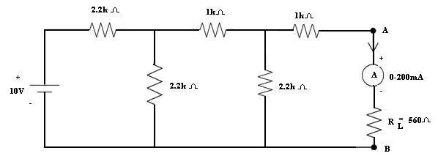
Fig-1
V_{th} :
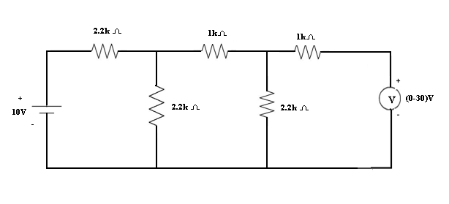

Fig-2

I_{l} :

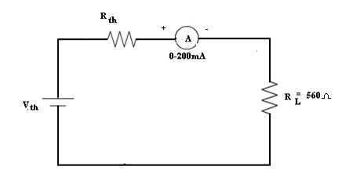
Fig-3

Procedure:

- Connections are made as per the circuit shown in fig (1).

- DC voltage is applied to the circuit and the current I_{L} flowing through the load is noted down.

- Circuit is connected as shown in fig (2). DC voltage is applied the reading of Ammeter is noted down as I_{N}.

- Circuit is connected as shown in fig (3). DC voltage is applied the reading of Voltmeter is noted down as V_{th}.
- The circuit is connected as shown in fig (4) and the effective resistance R_{th} / R_{N} is measured with the help of a multimeter.
- Thevenin’s equivalent circuit is connected as shown in fig (5) and the ammeter reading is noted down as I_{L}¹ .

- Thevenin’s theorem can be verified by checking that the currents I_{L} and I_{L}¹ are equal.

- Norton’s equivalent circuit is connected as shown in fig (6) and the ammeter reading is noted down as I_{L}¹ .

- Norton’s theorem can be verified by checking that the currents I_{L} and I_{L}¹ are equal.

Theoretical Calculations:

Observations:

Thevenin’s Theorem:

 |  | Theoretical values |  |  |  |  |  | Practical values
Vs(V)
Vs(V) | I_{L} | (A) | Vth(V) | Rth(Ω) |  | I_{L} ¹(A) | I_{L}(A) | Vth(V) | Rth(Ω) | I_{L}¹(A)

Norton’s Theorem:

 |  | Theoretical values |  |  |  |  |  | Practical values
Vs(V)
Vs(V) | I_{L}(A) |  | I_{N}(A) | R_{N}(Ω) |  | I_{L} ¹(A) | I_{L}(A) | I_{N}(A) | R_{N}(Ω) | I_{L}¹(A)

Precautions:

- Making loose connections are to be avoided.

- Readings should be taken carefully without parallax error

Result:

Viva Questions:

- What is the statement of Thevenins theorem?
- How you will calculate the Thevenins resistance?
- Why Thevenins resistor is connected in series with load resistance?
- What is the aim of the Thevenin’s theorem?
- What is the statement of Norton’s theorem?
- How you will calculate the Norton’s resistance?
- How you will calculate the Norton’s current?
- Why Norton’s resister is connected in parallel with load resistance?
- What is the aim of the Norton’s theorem?
- How to calculate Vth?
- How to calculate Rth?
- What is linear bilateral network?
- Draw the equivalent circuit of Thevenin’s Theorem.
- Draw the equivalent circuit of Norton’s Theorem.
- Two resistances of 5Ω and 20Ω are connected in parallel. The parallel combination is connected in series with a 1Ω resistance and this series parallel combination is connected is connected across a dc source of 100v.Determine the current supplied by the source.
- Three resistances of 3Ω each are connected in delta. What is the value of resistances in the equivalent star?
- The voltage at the terminals of a particular power supply on no load is 11.5v.when a 5w load is attached, the voltage drops to 8v.Determine Visors for this practical source.
- The voltage at the terminals of a particular power supply on no load is 11.5v.when a 5w load is attached, the voltage drops to 8v.What would be the terminal voltage of the source when a 10Ω load resistor is connected?
- The voltage at the terminals of a particular power supply on no load is 11.5v.when a 5w load is attached, the voltage drops to 8v.How much current could be drawn from this power supply under short circuit conditions?
- An incandescent light bulb rated at 70w dissipates 50w as heat and light when connected across a 230v ideal voltage source. If four such bulbs are connected in series across the same source. Determine the power each bulb will dissipate.
- Two resistances of 5Ω and 20Ω are connected in parallel. The parallel combination is connected in series with a 1Ω resistance and this series parallel combination is connected is connected across a dc source of 100v.How much current supplied by the source.
- The equivalent circuit of a network represented by thevenin’s equivalent with V_{th}=12v and R_{th}=8Ω is connected to a load resistance R_{L}. If the conditions for maximum power transfer exits. Determine the value of R_{L},
- The equivalent circuit of a network represented by thevenin’s equivalent with V_{th}=12v and R_{th}=8Ω is connected to a load resistance R_{L}. If the conditions for maximum power transfer exits. Determine the Power developed in R_{L.}
- The equivalent circuit of a network represented by thevenin’s equivalent with V_{th}=12v and R_{th}=8Ω is connected to a load resistance R_{L}. If the conditions for maximum power transfer exits. Determine the Efficiency of the circuit.
- Two resistances of 6Ω and 10Ω are connected in parallel. The parallel combination is connected in series with a 2Ω resistance and this series parallel combination is connected is connected across a dc source of 100v.Determine the current supplied by the source.
- Three resistances of 6Ω each are connected in delta. What is the value of resistances in the equivalent star?
- The voltage at the terminals of a particular power supply on no load is 11.5v.when a 5w load is attached, the voltage drops to 10v.Determine Visors for this practical source.
- The voltage at the terminals of a particular power supply on no load is 11.5v.when a 5w load is attached, the voltage drops to 10v.What would be the terminal voltage of the source when a 10Ω load resistor is connected?
- The voltage at the terminals of a particular power supply on no load is 1.5v.when a 5w load is attached, the voltage drops to 8v.How much current could be drawn from this power supply under short circuit conditions?
- An incandescent light bulb rated at 40w dissipates 30w as heat and light when connected across a 230v ideal voltage source. If four such bulbs are connected in series across the same source. Determine the power each bulb will dissipate.
- Two resistances of 15Ω and 20Ω are connected in parallel. The parallel combination is connected in series with a 1Ω resistance and this series parallel combination is connected is connected across a dc source of 100v.How much current supplied by the source.
- The equivalent circuit of a network represented by thevenin’s equivalent with V_{th}=15v and R_{th}=2Ω is connected to a load resistance R_{L}. If the conditions for maximum power transfer exits. Determine the value of R_{L}.
- The equivalent circuit of a network represented by thevenin’s equivalent with V_{th}=10v and R_{th}=5Ω is connected to a load resistance R_{L}. If the conditions for maximum power transfer exits. Determine the Power developed in R_{L},
- The equivalent circuit of a network represented by thevenin’s equivalent with V_{th}=15v and R_{th}=6Ω is connected to a load resistance R_{L}. If the conditions for maximum power transfer exits. Determine the Efficiency of the circuit.

Expt No: 2
Superposition, Reciprocity and Maximum Power Transfer Theorems

Aim: To verify Superposition, Reciprocity and Maximum power transfer theorems theoretically and practically.

Apparatus :

S.No | Name of the equipment | Range | Type | Quantity
1. | Ammeter | 0-200mA | Digital | 1
2. | Voltmeter | 0-30V | Digital | 1
3. | DC Power Supply | 0-15V | Dual | 2
4. | Multimeter | ……….. | Digital | 1
5. | Kit board | ………. | ……. | 1
6. | Connecting wires | ………. | ……….. | as per need

Theory:

Superposition Theorem Statement

In any linear bilateral network containing two or more energy sources the response at any element is equal to the algebraic sum of the responses caused by the individual sources.

While considering the effect of individual sources, the other ideal voltage sources and ideal current sources in the network are replaced by short circuit and open circuits respectively, across the terminals. This theorem is valid only for linear systems.

Reciprocity Theorem Statement

In any linear bilateral network containing the response at any branch (or) transformation ratio is same even after interchanging the sources.i.e. V/ I₁ = V/ I₂

Theoretical Calculations:

Circuit Diagrams of Superposition Theorem
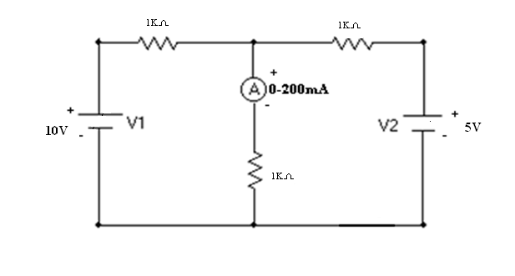
Fig 1
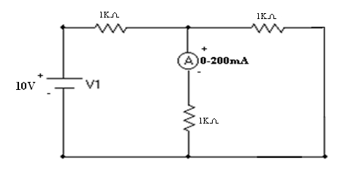
Fig 2
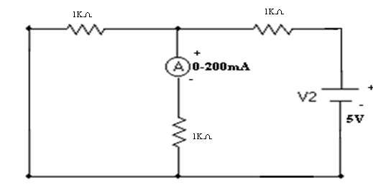
Fig 3
Circuit Diagrams of Reciprocity Theorem:
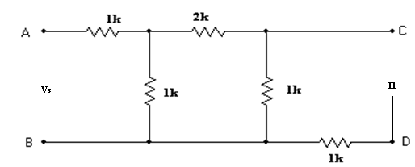
Fig.4
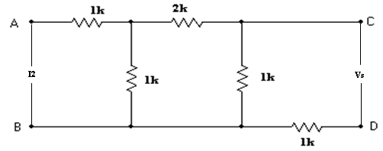
Fig.5
Procedure:

Superposition Theorem:

- The circuit is connected as shown in fig (1).

- Both the voltages V₁ and V₂ applied and the current through load resistor is noted as I_{X}.

- Supply voltage V₂ is replaced with short circuit and V₁ is applied as shown in fig (2) and the current through load resistor is noted down as I_{Y.}

- Supply voltage V₁ is replaced with short circuit and V₂ applied as shown in fig (3) and the current through load resistor is noted down as I_{Z.}

- It can be verified that I_{X} = I_{Y} + I_{Z} theoretically and practically which proves Superposition theorem.

Reciprocity Theorem:

- The circuit is connected as shown in fig (4).

- The ammeter reading is noted down as I₁.

  - Now the source and ammeter are interchanged as in fig

- The ammeter reading is noted down as I_{2.}.

- It can be veried that Vs/ I₁ = Vs/ I₂ theoretically and practically which proves Reciprocity theorem.

Super position theorem application:
- It is useful for electrical calculation of the circuits.
- Also used in transmission line drive calculation.
- Also to determine how long it will take a digital signal to go down a bus or a backplane
- This theorem interesting way to simplify circuit diagram allowing to search partial solution in the selected zone to be analyzed.
- It is used to transmission lines.

Observations:

Superposition Theorem

When both the sources are acting: fig (1)

Theoretical Practical
VS1(V) VS2(V)
I_{X}(A) I_{X}(A)

When V₁ source alone is acting: fig (2)

Theoretical Practical
VS1(V) VS2(V)
I_{y}(A) I_{y}(A)

When V₂ source alone is acting: fig (3)

VS1(V) | VS2(V) | I_{Z}(A) | I_{Z}(A)

Reciprocity Theorem:

Before interchanging the sources: fig (1)

 | Theoretical |  | values | Practical |  | values
Vs(V)
Vs(V) | I₁(A) |  | Vs/ I₁(Ω) | I₁(A) |  | Vs/ I₁(Ω)

After interchanging the sources: fig (2)

 | Theoretical |  | values | Practical |  | values
Vs(V)
Vs(V) | I₂(A) |  | Vs/ I₂(Ω) | I₂(A) |  | Vs/ I₂(Ω)

Precautions:

- Making loose connections are to be avoided.

- Readings should be taken carefully without parallax error.

Result:

Maximum power transfer theorem:

Theory:

Theorem Statement

It states that the maximum power is transferred from the source to the load, when the load resistance is equal to the source resistance.

Theoretical Calculations:

Formulae required:

Theoretical I_{L} = | ^{V}th
Theoretical I_{L} = | R_{L} +R _{th}
Circuit Diagrams:
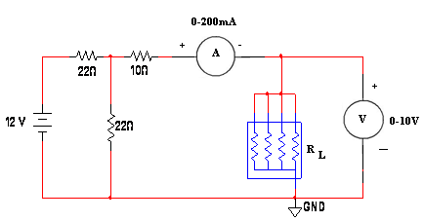
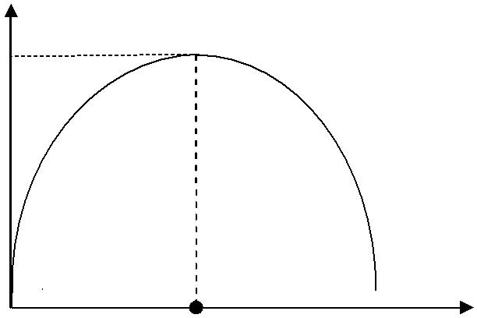
Model Graph:

P_{L}
P_{m}

R_{L} corresponding to P_{m} R_{L}(Ω)

Procedure:

- Connections are made as shown in fig (1).

- R_{L} is varied in steps and the reading of ammeter I_{L} is noted down in each step.

- The circuit is connected as shown in fig (2) and the effective resistance R_{th} is measured with the help of digital multimeter.

- Power delivered to load P_{L} is calculated in each step.

- A graph is drawn between P_{L} Vs R_{L} and R_{L} corresponding to maximum power is found from it.

It can be verified that R_{L} corresponding to maximum power from the graph is equal to the R_{th} (which is nothing but source resistance R_{S}) which proves the maximum power transfer theorem.

Tabular column:
 | S.No | R_{L}(Ω) |  | Theoretical values |  |  |  |  | Practical values
 |  |  | I = | ^{V}th |  | (A) |  | P_{L}= I_{L}²R_{L}(watts) | I_{L}(A) | P_{L}= I_{L}²R_{L} (watts)
 |  |  | I = | R + R |  |  |  | P_{L}= I_{L}²R_{L}(watts) | I_{L}(A) | P_{L}= I_{L}²R_{L} (watts)
 |  |  | L
 |  |  |  | L | th

Model Calculations:

Precautions:

- Making loose connections are to be avoided.

- Readings should be taken carefully without parallax error.

Result:

Viva Questions:
- What is the statement of Superposition theorem?
- How you will calculate the total resistance?
- State the super position theorem?
- What is meant by network?
- What is meant by bilinear network?
- Applications of superposition theorem?
- Can the theorem work for a circuit that has current sources and voltage sources mixed together?
- What is the practical application of a circuit that has multiple voltage sources?
- What is done to voltage sources while applying superposition theorem?
- What is done to current sources while applying superposition theorem?
11) What is bilateral circuit?
12) Statement of maximum power transfer theorem?

13) When the maximum power transfer theorem?

- What is meant by power? Mention its unit?

- What is meant by Energy?

- What are the applications?

- Mention the application of maximum power transform theorem?

- What is Network?

- What is impedance?

- What are the limitations of Super Position Theorem?

- Why Super Position theorem not applicable to power calculations?

- What is reciprocity?

- Find the current I in the circuit shown in figure using superposition theorem
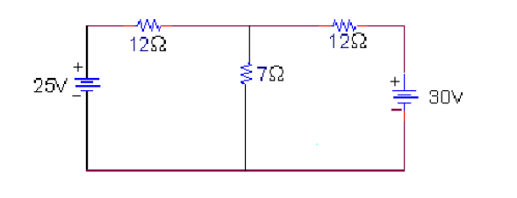

- A 6v battery having an internal resistance of 0.85Ω is connected to a load resistance R_{L}=3Ω. Determine the total power supplied to the load,

- A 6v battery having an internal resistance of 0.75Ω is connected to a load resistance R_{L}=4Ω. Determine the power dissipated and lost within the voltage source,

- A 8v battery having an internal resistance of 0.45Ω is connected to a load resistance R_{L}=7Ω. Determine the terminal voltage.

- A 6v battery having an internal resistance of 0.35Ω is connected to a load resistance R_{L}=8Ω. Determine the power supplied to the circuit when the voltage source is replaced by an ideal source with the same magnitude of source voltage.

- The voltage at the terminals of a particular power supply on no load is 12.5v.when a 5w load is attached, the voltage drops to 12v. Determine Vs&Rs for this practical source.

- The voltage at the terminals of a particular power supply on no load is 12.5v.when a 5w load is attached, the voltage drops to 12v. What would be the terminal voltage of the source when a 10Ω load resistor is connected?

- The voltage at the terminals of a particular power supply on no load is 12.5v.when a 5w load is attached, the voltage drops to 12v. How much current could be drawn from this power supply under short circuit conditions?

- An incandescent light bulb rated at 100w dissipates 100w as heat and light when connected across a 230v ideal voltage source. If four such bulbs are connected in series across the same source, determine the power each bulb will dissipate.

- Two resistances, each of 10Ω and 20Ω are connected in parallel across a dc voltage source. the current through the 10Ω resistance will be ?

- I have always viewed voltage sources as a battery of 1.5 Volt cells. These cells supply 1.5V (approx.) at whatever current is drawn, until they're dead. I find it difficult to conceptualise current sources, though. Is there a real-world current source that I can use to conceptualise such things?

- A battery of 1.5V cells, in my experience, is used to provide currents at about 1 to 100 milliamps. What kind of voltages should one expect from a current source?
- A 6v battery having an internal resistance of 0.45Ω is connected to a load resistance R_{L}=6Ω. Determine the terminal voltage.

- A 8v battery having an internal resistance of 0.35Ω is connected to a load resistance R_{L}=8Ω. Determine the power supplied to the circuit when the voltage source is replaced by an ideal source with the same magnitude of source voltage.

- The voltage at the terminals of a particular power supply on no load is 12.5v.when a 5w load is attached, the voltage drops to 15v. Determine Vs & Rs for this practical source.

- The voltage at the terminals of a particular power supply on no load is 12.5v.when a 5w load is attached, the voltage drops to 15v. What would be the terminal voltage of the source when a 12Ω load resistor is connected?

- The voltage at the terminals of a particular power supply on no load is 12.5v.when a 5w load is attached, the voltage drops to 12v. How much current could be drawn from this power supply under short circuit conditions?

- An incandescent light bulb rated at 200w dissipates 200w as heat and light when connected across a 230v ideal voltage source. If four such bulbs are connected in series across the same source, determine the power each bulb will dissipate.

- Two resistances, each of 20Ω and 40Ω are connected in parallel across a dc voltage source. the current through the 20Ω resistance will be ?

- A 6v battery having an internal resistance of 0.45Ω is connected to a load resistance R_{L}=3Ω. Determine the terminal voltage.

- Two resistances of 6Ω and 10Ω are connected in parallel. The parallel combination is connected in series with a 2Ω resistance and this series parallel combination is connected is connected across a dc source of 200v.Determine the current supplied by the source.

- Two resistances of 7Ω and 15Ω are connected in parallel. The parallel combination is connected in series with a 2Ω resistance and this series parallel combination is connected is connected across a dc source of 50v.How much current supplied by the source.

EXPT:3
Locus Diagrams Of Series RL And RC Circuits
Aim:
To draw the current locus diagrams for series RL and RC circuits by varying resistance.

Apparatus :
:

S. No | Name of the apparatus | Range | Type | Quantity
1 | Signal generator | (0 – 3M) Hz, (0-20) VPP | - | 1No
2 | Decade Resistance Box | (0-111.11K)Ω | - | 1No
3 | Decade inductance Box | (0-1.11)H | - | 1No
4 | Decade Capacitance Box | (0-1.11)F | - | 1No
5 | Ammeter | (0-2000m)A | MC | 1No
6 | Connecting wires | - | - | Required number

Precautions:
1. Initially keep the RPS output voltage knob in zero volt position.
2. Set the ammeter pointer at zero position.
3. Take the readings without parallax error.
4. Avoid loose connections.
5. Avoid short circuit of Function Generator output terminals.

Model Graphs:
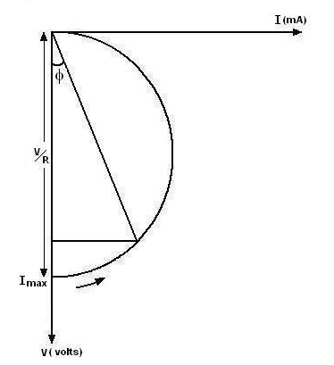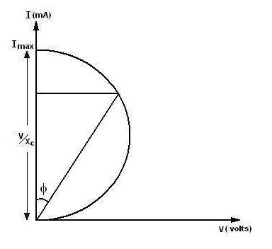

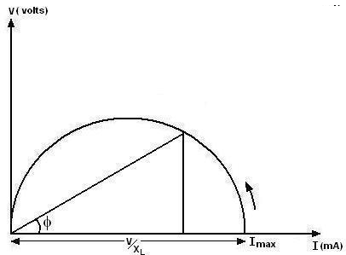

Procedure :

Series RL circuit (varying resistance):

- Set the signal generator to be in sine wave mode and adjust the output voltage to 20V peak-to-peak, frequency to 200 Hzs.
- Connect the circuit as per fig (7.1).
- Vary the resistance in the circuit using DRB in steps and note down the current through the circuit for each step (ammeter reading).
- Calculate phase angle φ using to formula φ = tan-1 $\left(\frac{X_{L}}{R}\right)$ for each step.
- Disconnect the circuit.
- Plot the current locus diagram by taking current on x axis and voltage on Y – axis.

Series RC circuit( varying resistance ):

- Set the signal generator to be in sine wave mode and adjust the output voltage to 20V peak to peak,frequency to 200 Hzs.
- Connect the circuit as per fig(7.2).
- Vary the resistance in the circuit using DRB in steps and note down the current through the circuit for each step(ammeter reading).
- Calculate phase angle φ using to formula φ = tan-1 $\left(\frac{X_{C}}{R}\right)$ for each step.
- Disconnect the circuit.
- Plot the current locus diagram by taking current on Y axis and voltage on X – axis.
Series RC circuit (varying capacitance):
- Set the signal generator to be in sine wave mode and adjust the output voltage to 20V peak-to-peak, frequency to 200 Hzs.
- Connect the circuit as per fig (7.3).
- Vary the Capacitance in the circuit using DCB in steps and note down the current through the circuit for each step (ammeter reading).
- Calculate phase angle φ using to formula φ = tan-1 $\left(\frac{X_{C}}{R}\right)$ for each step.
- Disconnect the circuit.
- Plot the current locus diagram by taking current on Y-axis and voltage on X – axis.

Circuit Diagrams:

Series RL circuit (R Varying):
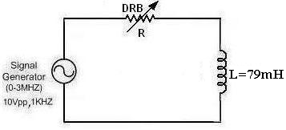

Series RC circuit (RVarying):
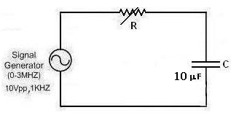
Set up for series R-L circuit:

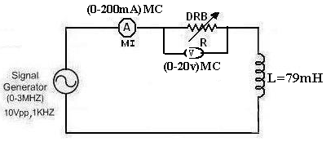

Set up for series R-c circuit:
`
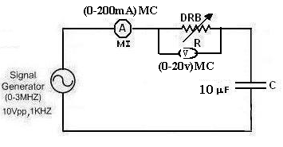
Theory:
A phasor diagram may be drawn and is expanded to develop a curve; known as a locus. Locus diagrams are useful in determining the behavior or response of an RLC circuit when one of its parameters is varied while the frequency and voltage kept constant. The magnitude and
phase of he current vector in the circuit depends upon the values of R,L, and C and frequency at the fixed source voltage. The path traced by the terminus of the current vector when the parameters R<L or of are varied while f and V are kept constant is called the current locus.
The term circle diagram identifies locus plots that are either circular or semi circular loci of the terminus ( the tip of the arrow) of a current phasor or voltage phasor. Circle diagrams are often employed as aids in analyzing the operating characteristics of circuits like equivalent circuit of transmission lines and some types of AC machines.
Tabular Column:

S.NO | Current in circuit (mA) | Voltage across rheostat(v) | resistance | Φ=${\text{tan}}^{−1}\left(\frac{\text{Xl}}{R}\right)$

S.NO | Current in circuit (mA) | Voltage across rheostat(v) | resistance | Φ=${\text{tan}}^{−1}\left(\frac{X_{C}}{R}\right)$

Result:

Viva Questions:-

1. What is RC circuit
2. What is the Q factor of series circuit
3. What is RL circuits
4. What is Locus

LAB ASSIGNMENT:

- Draw the locus diagram for the given circuit at 30V peak-to-peak, frequency to 150 Hzs.

Expt. No: 4

Series and Parallel Resonance

Aim: To verify Resonant Frequency, Bandwidth & Quality factor of RLC Series and Parallel Resonant circuits.

Apparatus:

S.No | Name of the equipment | Range | Type | Quantity
1. | CRO | (0-20)MHz | Dual | 1
2. | Series and parallel resonance kit |  |  | 1
3. | Connecting wires |  |  | as per need

Theory:

The voltage across the inductor is V_{L} = I X_{L}
the voltage across the capacitor is V_{C} = IX_{C}
the voltage across the resistor is V_{R} = IR
Phase relations among these voltages are shown in Figure 1 The voltage across the resistor is in phase with the current. The voltage across the inductor leads the current by 90 degrees.
The voltage across the capacitor lags the current by 90 degrees. The total voltage across the resistor, inductor and capacitor should be equal to the emf supplied by the generator.

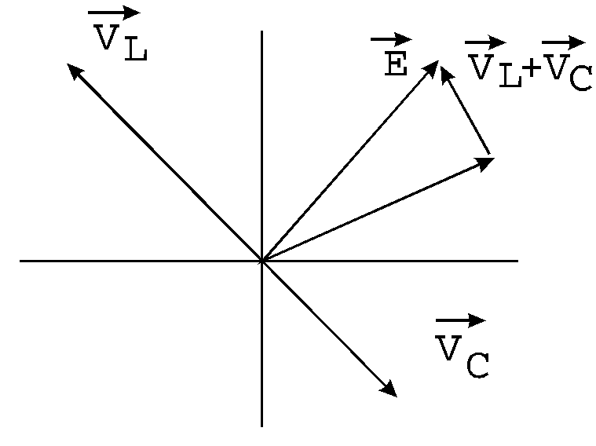
Figure 1
From Figure 2 we can see that
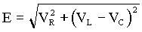
If we divide both sides of this equation by current, we will get
E/I = Z = R² + (X_{L} - X_{C}) ²,
Where (X_{L} - X_{C}) is called the total reactance and Z is called the impedance of the circuit.
We know that the capacitive reactance X_{C} = 1/ωC, and the inductive reactance X_{L} = ωL depend on frequency. The value of frequency when
X_{L} = X_{C}, ωL = 1/ωC, or
ω= 1/√LC = ω₀ = 2f₀
The frequency f₀ is called the resonance frequency of the circuit. At this frequency, the impedance is smallest and the maximum value of the current (and the voltage across the resistor V_{R}) can be obtained. At this frequency, the circuit is said to be at resonance. At resonance, the current is in phase with the generator voltage.
If we measure voltage across the resistor, depending on frequency, we will obtain a resonance curve of the circuit as shown in Figure2. A resonance curve can be characterized by the resonance width ∆f, the frequency difference between the two points on the curve where the power is half its maximum value or voltage is
V_{max}/√LC = 0.707 V_{max}
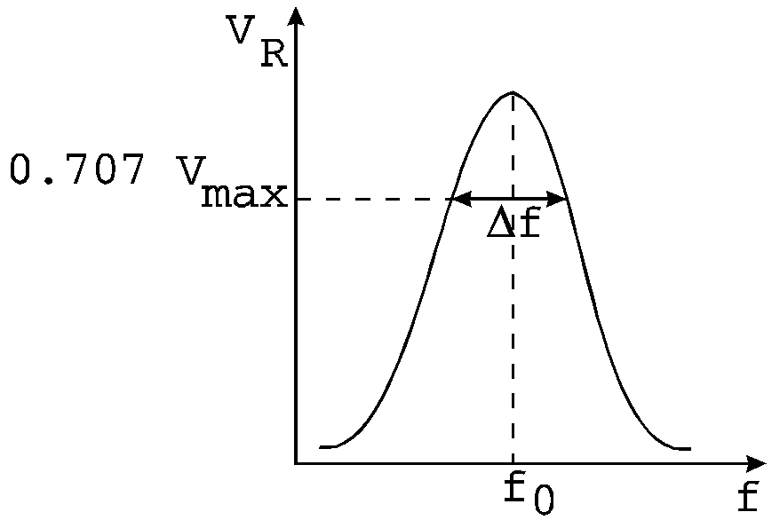
Figure 2
When the width is small compared with the resonance frequency, the resonance is sharp; that is, the resonance curve is narrow. The circuit can be characterized by the quality factor Q = f₀/∆f.
If resistance is small and resonance is sharp, the quality factor is large. When the resistor is large, the quality is small. Q is a measure of the rate at which energy is dissipated in the circuit if the AC voltage source across the series circuit was removed.

Parallel Resonance:

Theory:

The parallel RLC circuit is very common in radio and TV circuits. The circuit analysis follows from Kirchhoff’s laws, but is not in many beginning texts. The common terminal voltage V is across each element (see Fig. 3a), and the instantaneous current i is the algebraic sum of the instantaneous, i_{f}, and i_{c}.
Since i_{R} is in phase with V, but i_{L} lags V by 90⁰, and i_{c} leads V by 90⁰, we can describe the situation by the rotating vectors in Fig. 5b where I is the vector sum of I_{R}, I_{L}, and I_{C}. Hence from Fig 3b

Figure 3: A parallel LRC circuit.

Theoretical Calculations:

Formulae Required :

Series Resonance:

1. Resonant frequency, fo = ¹
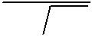
2π LC

- Quality factor, Q = X_{L}/R =2πf_{º}L/R

- Bandwidth, BW = f_{º}/Q
Parallel Resonance:
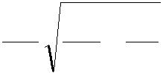
1. | Resonant frequency, f |  |  |  | o |  |  | = | 1 | 1 |  | − | R²
 |  |  |  |  |  |  |  |  | 2π | LC |  | − | L²
2. | Quality factor, Q = |  | R |  |  | = |  |  | R
2. |  |  |  |  |  |  |  |  | 2π f_{o}L
 |  |  | X_{L}
3. | Bandwidth, BW = | f_{o}
3. | Bandwidth, BW = | Q

Procedure:

Series Resonance:

- Circuit is connected as shown in the fig (1).

- A fixed voltage is applied to the circuit through function generator.

- The frequency is varied in steps and the corresponding ammeter reading is noted down as I_{s}.

- A graph is drawn between frequency f and current I_{s}. Resonant frequency (f_{o}) and Half power frequencies (f_{1,} f₂) are marked on the graph.

5. Bandwidth = (f₂-f_{1.}) & Quality factor Q = | f ₀ | are found from the graph.
5. Bandwidth = (f₂-f_{1.}) & Quality factor Q = | BW | are found from the graph.
6. Practical values of Resonant Frequency, Q-factor and Bandwidth are compared with theoretical values.

Parallel Resonance:

- Circuit is connected as shown in the fig (2)

- A fixed voltage is applied to the circuit through function generator.

- The frequency is varied in steps and the corresponding ammeter reading is noted down as I_{p}.

- A graph is drawn between frequency f and current I_{p}. Resonant Frequency (f_{o}) and Half power frequencies (f_{1,} f₂) are marked on the graph.

5. Bandwidth = (f₂-f_{1.}) & Quality factor Q = | f ₀ | are found from the graph.
5. Bandwidth = (f₂-f_{1.}) & Quality factor Q = | BW | are found from the graph.
6. Practical values of Resonant Frequency, Q-factor and Bandwidth are compared with theoretical values.

Circuit Diagram of Series Resonance:

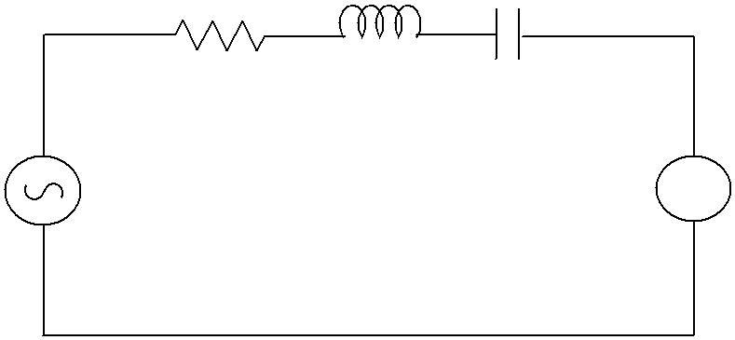
1kΩ 30mH 0.1µf

Signal generator A

Fig-1

Model Graph:

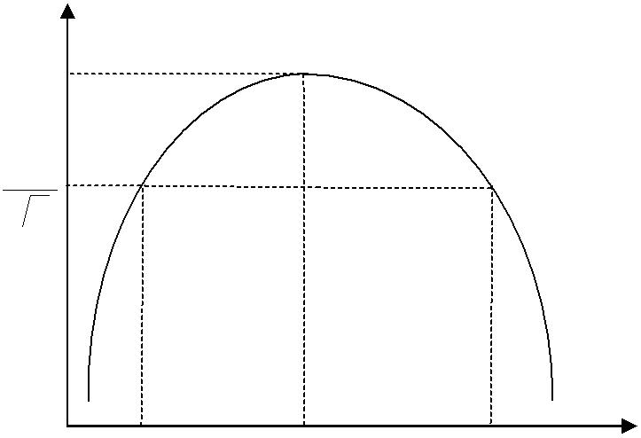
^{I}max

^{I}max 2

f₁ f₀ f₂ f(Hz)

Circuit Diagram of Parallel Resonance

1k Ω 30mH
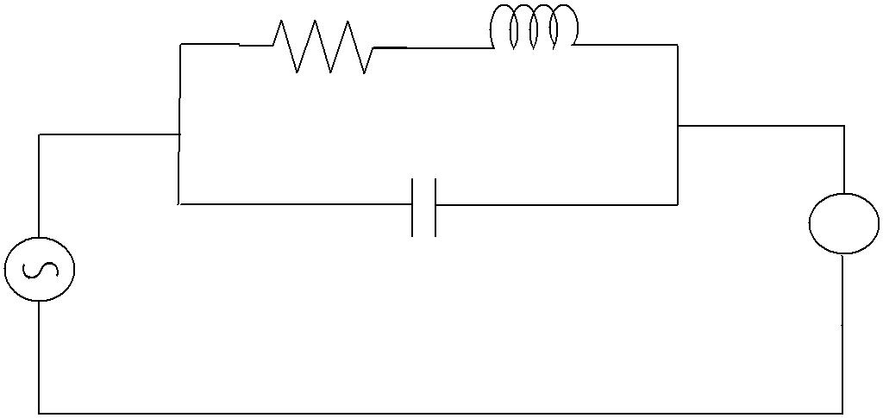

A
Vs 0.1µf

Fig-2

Model Graph:

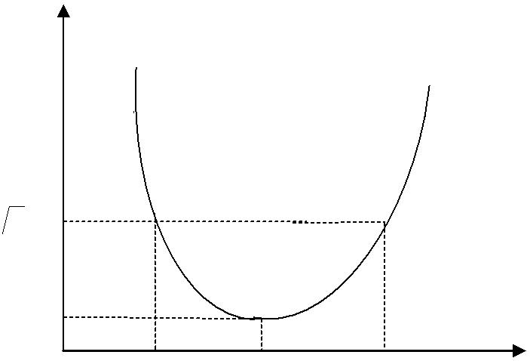
I_{P}

^{2I}min

^{I}min
f₁ f₀ f2 f (Hz)
Observations:

Series Resonance |  |  |  |  | Parallel Resonance
S.No. | Frequency (Hz) | Current(I_{s})  Amp |  | S.No. | Frequency (Hz) | Current(I_{p})Amp

Result Table:

 | Series Resonance |  | Parallel Resonance
 | Theoretical | Practical | Theoretical | Practical
Resonant frequency(f₀)Hz
Bandwidth(BW)
Quality factor(Q)
Precautions:

- Making loose connections are to be avoided.

- Readings should be taken carefully without parallax error.

Result:

VIVA QUESTIONS:
1. Define resonance?
2. Difference between series & parallel resonance?
3. Define band width?
4. Define quality factor?
5. What is the relation between bandwidth & quality factor?
6. What is the lower &upper cutoff frequency?
7. What is the formula for RC series network using laplace transform?
8. Explain initial conditions of capacitance?
9. Explain types of elements?
10. Which capacitor is preferred for high voltage and frequency?
11. What are the material used for resistor?
12. What happens to voltage when current through the inductor is constant?
13. How will you define capacitance?
14. When we use 3 terminal resistor?
15. What are the material used for inductance coil?
16. Define Resonance and 3dB points?
17. What is phase difference between voltage and current in inductor and capacitor? Which is
leading?
18. Define Selectivity, Bandwidth and Q-factor?
19. For RLC circuit what is the power factor at the lowest frequency?
20. What are the expressions for admittance, conductance and suceptance and also write its units

- To find the Resonant Frequency, Bandwidth & Quality factor of RLC
Series and Parallel Resonant circuits. (R=1KΩ, L=70mh, C=0.01µf).

22. To find the Resonant Frequency, Bandwidth & Quality factor of RLC
Series circuit. (R=1KΩ, L=30mh, C=0.01µf).

23. To find the Resonant Frequency, Bandwidth & Quality factor of RLC
Parallel circuit. (R=1KΩ, L=30mh, C=0.01µf).

24. To find the Resonant Frequency and Bandwidth of RLC Series circuit (R=2KΩ, L=30mh, C=0.01µf).

25. To find the Resonant Frequency and Bandwidth of RLC Parallel circuit (R=1KΩ, L=30mh, C=0.1µf).

26. To find the Resonant Frequency and Bandwidth of RLC Series circuit (R=1KΩ, L=100mh, C=0.1µf).

27. To find the Resonant Frequency and Bandwidth of RLC Series Parallel circuit (R=1KΩ, L=100mh, C=0.01µf).

28. To find the Resonant Frequency and Bandwidth of RLC Parallel circuit (R=5KΩ, L=100mh, C=0.001µf).

29. To find the Resonant Frequency and Bandwidth & band width of RLC Series circuit (R=1KΩ, L=70mh, C=0.01µf).

30. To find the Resonant Frequency and Bandwidth of RLC Parallel circuit (R=2KΩ, L=100mh, C=0.1µf).

31. To find the Resonant Frequency, Bandwidth & Quality factor of RLC
Series and Parallel Resonant circuits. (R=2KΩ, L=35mh, C=0.01µf).

32. To find the Resonant Frequency, Bandwidth & Quality factor of RLC
Series circuit. (R=2KΩ, L=60mh, C=0.01µf).

33. To find the Resonant Frequency, Bandwidth & Quality factor of RLC
Parallel circuit. (R=2KΩ, L=60mh, C=0.01µf).

34. To find the Resonant Frequency and Bandwidth of RLC Series circuit (R=4KΩ, L=60mh, C=0.01µf).

35. To find the Resonant Frequency and Bandwidth of RLC Parallel circuit (R=2KΩ, L=60mh, C=0.1µf).

36. To find the Resonant Frequency and Bandwidth of RLC Series circuit (R=2KΩ, L=200mh, C=0.1µf).

37. To find the Resonant Frequency and Bandwidth of RLC Series Parallel circuit (R=2KΩ, L=200mh, C=0.01µf).

38. To find the Resonant Frequency and Bandwidth of RLC Parallel circuit (R=5KΩ, L=100mh, C=0.001µf).

39. To find the Resonant Frequency and Bandwidth & band width of RLC Series circuit (R=2KΩ, L=35mh, C=0.01µf).

40. To find the Resonant Frequency and Bandwidth of RLC Parallel circuit (R=4KΩ, L=200mh, C=0.1µf).

Expt. No:5

Time Response of Series RL and RC Circuits

Aim: To draw the time response of first order series RL and RC network for periodic Non-Sinusoidal function and verify the time constant.

Apparatus:

S.No | Name of the equipment | Range | Type | Quantity
1. | Function generator | (0-100)MHz | digital | 1
2. | Decade Resistance box | -------- | ------------ | 1
3. | Decade Inductance box | -------- | ---------- | 1
4. | Decade Capacitance box | ----------- | ----------- | 1
5. | CRO | (0-20)MHz | Dual | 1
6. | CRO probes |  |  | 1
7. | Connecting wires |  |  | As required

Theory:

Theoretical Calculations:

Formulae required:

For RL Series circuit, Time constant,τ =
For RC Series circuit, Time constant, τ = RC

Circuit diagrams:

Series RL Circuit
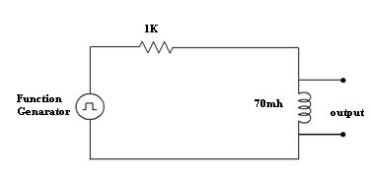

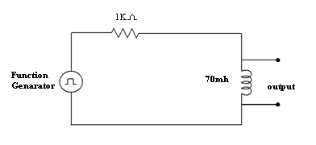

Series RC Circuit

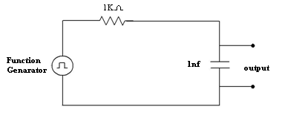

Model Graph:

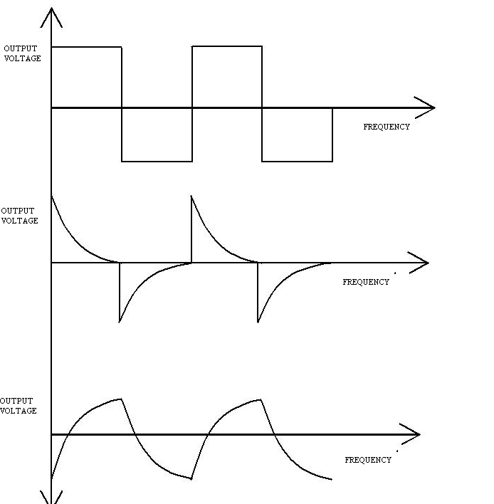

Procedure:

Series RL Circuit:

- Connections are made as shown in the fig-1.

- Input voltage (Square wave) is set to a particular value.

- The waveform of voltage across inductor is observed on CRO and the waveform is drawn on a graph sheet.

- The time constant is found from the graph and verified with the theoretical value.

Series RC Circuit:

- Connections are made as shown in the fig-2.

- Input voltage (Square wave) is set to a particular value.

- The waveform of voltage across the capacitor is observed on CRO and the waveform is drawn on a graph sheet.

- The time constant is found from the graph and verified with the theoretical value.

Result table:
 | Series RL Circuit |  | Series RC Circuit
 | Theoretical | Practical | Theoretical |  | Practical
Time Constant(τ)
Precautions:

- Making loose connections are to be avoided.

- Readings should be taken carefully without parallax error.

Result:

VIVA QUESTIONS:
1. Define the terms
i) Time response ii) Frequency response
2. Define the terms
i) Transient state ii) Steady state response
3. Define damping ratio?
4. Define Transient time?
5. Explain the different regions in frequency response?
6. State the frequency for RC phase shift oscillator?
7. What do you mean by Conductivity?
8. Define resonance?
9. What is the phase difference between voltage and current in a capacitor? Which is leading?
10. What is the phase difference between voltage and current in a inductor? Which is leading?
11. What is the effect of resistance in RLC circuit?
12. For RLC circuit what is power factor at lowest power frequency?
13. What is the locus of voltage phaser across R in series RLC circuit?
14. Define bandwidth?
15. Define cutoff frequency?
16. Differentiate between transient state, transient time and transient response?
17. Define natural response and natural frequency?
18. Define time constants for RC and RL circuits?
19. What is meant by rise time, settling time and delay time?
20. What is meant by damping ratio?
21. To draw the time response of first order series RL and RC network (R=1KΩ, L=30mh,c=0.01µf )for periodic Non-Sinusoidal function and verify the time constant.
22. To draw the time response of first order series RL and RC network (R=2KΩ, L=40mh,c=0.021µf )for periodic Non-Sinusoidal function and verify the time constant.
23. To draw the time response of first order series RL and RC network (R=3KΩ, L=30mh,c=0.01µf )for periodic Non-Sinusoidal function and verify the time constant.
24. To draw the time response of first order series RL and RC network (R=1KΩ, L=40mh,c=0.01µf )for periodic Non-Sinusoidal function and verify the time constant.
25. To draw the time response of first order series RL and RC network (R=1KΩ, L=40mh,c=0.31µf )for periodic Non-Sinusoidal function and verify the time constant.
26. To draw the time response of first order series RL and RC network (R=1KΩ, L=40mh,c=0.11µf )for periodic Non-Sinusoidal function and verify the time constant.
27. To draw the time response of first order series RL and RC network (R=2KΩ, L=40mh,c=0.02µf )for periodic Non-Sinusoidal function and verify the time constant.
28. To draw the time response of first order series RL and RC network (R=1KΩ, L=33mh,c=0.21µf )for periodic Non-Sinusoidal function and verify the time constant.
29. To draw the time response of first order series RL and RC network (R=3KΩ, L=40mh,c=0.21µf )for periodic Non-Sinusoidal function and verify the time constant.
30. To draw the time response of first order series RL and RC network (R=2KΩ, L=35mh,c=0.36µf )for periodic Non-Sinusoidal function and verify the time constant.
31. To draw the time response of first order series RL and RC network (R=2KΩ, L=60mh,c=0.01µf )for periodic Non-Sinusoidal function and verify the time constant.
32. To draw the time response of first order series RL and RC network (R=4KΩ, L=80mh,c=0.021µf )for periodic Non-Sinusoidal function and verify the time constant.
33. To draw the time response of first order series RL and RC network (R=6KΩ, L=60mh,c=0.01µf )for periodic Non-Sinusoidal function and verify the time constant.
34. To draw the time response of first order series RL and RC network (R=2KΩ, L=80mh,c=0.01µf )for periodic Non-Sinusoidal function and verify the time constant.
35. To draw the time response of first order series RL and RC network (R=2KΩ, L=80mh,c=0.31µf )for periodic Non-Sinusoidal function and verify the time constant.
36. To draw the time response of first order series RL and RC network (R=2KΩ, L=80mh,c=0.11µf )for periodic Non-Sinusoidal function and verify the time constant.
37. To draw the time response of first order series RL and RC network (R=4KΩ, L=80mh,c=0.02µf )for periodic Non-Sinusoidal function and verify the time constant.
38. To draw the time response of first order series RL and RC network (R=2KΩ, L=66mh,c=0.21µf )for periodic Non-Sinusoidal function and verify the time constant.
39. To draw the time response of first order series RL and RC network (R=6KΩ, L=80mh,c=0.21µf )for periodic Non-Sinusoidal function and verify the time constant.
40. To draw the time response of first order series RL and RC network (R=4KΩ, L=70mh,c=0.36µf )for periodic Non-Sinusoidal function and verify the time constant.

Expt. No:6

Two Port Network Parameters (Z, Y Parameters)

Aim: To obtain experimentally Z, Y parameters and of a given two port network.

Apparatus:

S.No | Name of the equipment | Range | Type | Quantity
1. | Ammeter | (0-200)mA | Digital | 2
2. | Voltmeter | (0-20)V | Digital | 2
3. | DC Power Supply | (0-30)V | Dual | 1
4. | Digital Multimeter |  | digital | 2
5. | Connecting wires |  |  | as per need

Theory:

To represent the general nature of a network, it is normally represented by a rectangular box. If a conductor is fastened to a node in the network and brought for access the end of the conductor is called a terminal. Terminals are required for connecting driving force to the network, for connecting load or making measurements.
The minimum number of terminals that are useful are two. One pair of terminals is given the name Port. In the two port network shown in fig 1 we have four variable identified by two voltages and two currents. We assume that the variables transform quantities and use V1 and I1 as variables at the input port 1, V2 and I2 as the variables at the output port 2. Now only two of the four variables are independent and the specific action of any two of them determines the remaining two.

Theoretical Calculations:

1) Z-parameters
The Z-parameters are also called as Impedance parameters.Z_{11,}Z₁₂ ,Z₂₁ ,Z₂₂
are the Z-parameters of the two port network..
V1= Z₁₁I1 + Z₁₂I2
V2= Z₂₁I1 + Z₂₂I2
- Input Impedance (Z₁₁) Z₁₁ is the input impedance when output is open circuited.
Z₁₁ = V1/I1 when I2=0
To measure Z₁₁ open circuit the output side of the two port network and apply voltage in the input side of the two port network then measure the V1 and I1 and substitute in the above equation.
- Reverse Transfer Impedance (Z₁₂) Z₁₂ is the mutual or reverse transfer impedance when input is open circuited.
Z₁₂ = V1/I2 when I1=0
To measure Z₁₂ open circuit the input side of the two port network and apply voltage in the output side of the two port network then measure the V1 and I2 and substitute in the above equation.
- Forward Transfer Impedance (Z2₁) Z₂₁ is the mutual or forward transfer impedance when output is open circuited.
Z₂₁ = V2/I1 when I2=0
To measure Z₂₁ open circuit the output side of the two port network and apply voltage in the input side of the two port network then measure the V2 and I1 and substitute in the above equation.

- Output Impedance (Z₂₂) Z₂₂ is the output impedance when output is open circuited.
Z₂₂ = V2/I2 when I1=0
To measure Z₂₂ open circuit the output side of the two port network and apply voltage in the input side of the two port network then measure the V2 and I2 and substitute in the above equation.
2) y-parameters
The Y-parameters are also called as Admittance parameters.Y_{11,}Y₁₂ ,Y₂₁ ,Y₂₂are the Y-parameters of the two port network..
I1= Y₁₁V1 + Y₁₂V2
I2= Y₂₁V1 + Y₂₂V2
- Input Admittance (Y₁₁) Y₁₁ is the input admittance when output is short circuited.
Y₁₁ = I1/V1 when V2=0
To measure Y₁₁ short circuit the output side of the two port network and apply voltage in the input side of the two port network then measure the V1 and I1 and substitute in the above equation.
- Reverse Transfer Admittance (Y₁₂) Y₁₂ is the mutual or reverse transfer admittance when input is short circuited.
Y₁₂ = I2/V1 when V2=0
To measure Y₁₂ short circuit the output side of the two port network and apply voltage in the input side of the two port network then measure the V1 and I2 and substitute in the above equation.
- Forward Transfer Admittance (Y₂₁) Y₂₁ is the mutual or forward transfer admittance when output is short circuited.
Y₂₁ = I1/V2 when V1=0
To measure Y₂₁ short circuit the input side of the two port network and apply voltage in the output side of the two port network then measure the V2 and I1 and substitute in the above equation.
- Output Admittance (Y₂₂) Y₂₂ is the output admittance when output is short circuited.
Y₂₂ = I2/V2 when V1=0
To measure Z₂₂ short circuit the input side of the two port network and apply voltage in the output side of the two port network then measure the V2 and I2 and substitute in the above equation.

Circuit diagram:

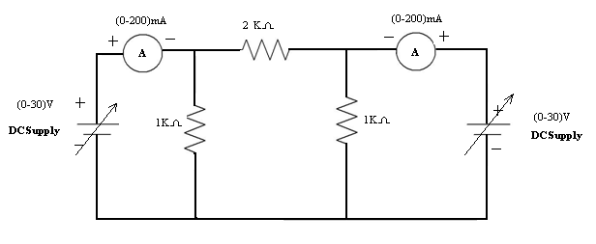

Procedure:

- Open Circuiting Output Terminals (I₂ = 0):

  - Connections are made shown in fig (1).

  - Supply is given to input port.

  - The readings of ammeter as I₁ and Voltmeter as V₂ are noted down.

2. Short circuiting output terminals (V₂ = 0):

  - Connections are made shown in fig (2).

  - Supply is given to input port.

  - The readings of ammeters as I₁& I₂ are noted down.

Observations:

When I₁=0

S.No. | V1(V) | I ₂(A) | V₂(V)
When I₂=0
S.No. | V₁(V) | I ₁(A) | V₂(V)

When V₁=0

S.No. | I ₂(A) | I 1(A) | V₂(V)

When V₂=0

S.No. | V1(V) | I₁(A) | I₂(A)

Result table:

 |  | Z Parameters |  |  |  |  |  |  |  |  | Y Parameters
 | Z11 (Ω) | Z12(Ω) |  | Z21(Ω) |  |  | Z22(Ω) |  | Y11(ᶷ) |  | Y12(ᶷ) |  | Y21(ᶷ) |  | Y22(ᶷ)
Theoretical
Practical

Precautions:

- Making loose connections are to be avoided.

- Readings should be taken carefully without parallax error.

Result:

VIVA QUESTIONS:
- What are the equations of open circuit parameters?
- How can we obtain the short circuit parameters?
- What are transmission parameters?
- What are the equations of hybrid parameters?
- What is the condition for symmetry and condition for reciprocity in two port network parameters?
- Define branch?
- Which parameter is leading in parallel RC circuit?
- Why parallel circuit is called rejector?
- What is the formula for current i(t) in RC series?
- Derive RC series network using DE?
11. What is transfer impedance?
12. Why Z-parameters are used?
1 3. What are applications of Z and Y parameters?
14. What are relations used in Z parameters?
15. What is the relation between Z and Y parameters?
16. To obtain experimentally Z, Y parameters and of a given two port ∏ network
(R=4KΩ, 2KΩ, 2KΩ).
17. To obtain experimentally Z, parameters and of a given two portT network
(R=1KΩ, 2KΩ, 2KΩ).
18. To obtain experimentally Y parameters and of a given two port T network
(R=2KΩ, 1KΩ, 2KΩ).
19. To obtain experimentally Z, Y parameters and of a given two port ∏ network
(R=1KΩ, 2KΩ, 2 KΩ).
20. To obtain experimentally Y parameters and of a given two portT network
(R=3KΩ, 5KΩ, 6KΩ).
21. To obtain experimentally Z, Y parameters and of a given two port ∏ network
(R=4KΩ, 8KΩ, 8KΩ).
22. To obtain experimentally Z, parameters and of a given two port∏ network
(R=3KΩ, 2KΩ, 2KΩ).
23. To obtain experimentally Y parameters and of a given two port T Network

(R=4KΩ, 6KΩ, 7KΩ).
24. To obtain experimentally Z, Y parameters and of a given two port∏ network
(R=4KΩ, 2KΩ, 2KΩ).
25. To obtain experimentally Z, Y parameters and of a given two port T network
(R=4KΩ, 12KΩ, 10KΩ).
26. To obtain experimentally Z, Y parameters and of a given two port ∏ network
(R=2KΩ, 4KΩ, 6KΩ).
27. To obtain experimentally Z, parameters and of a given two portT network
(R=2KΩ, 4KΩ, 2KΩ).
28. To obtain experimentally Y parameters and of a given two port T network
(R=4KΩ, 2KΩ, 4KΩ).
29. To obtain experimentally Z, Y parameters and of a given two port ∏ network
(R=4KΩ, 2KΩ, 2KΩ).
30. To obtain experimentally Y parameters and of a given two portT network
(R=6KΩ, 4KΩ, 6KΩ).
31. To obtain experimentally Z, Y parameters and of a given two port ∏ network
(R=2KΩ, 2KΩ, 6KΩ).
32. To obtain experimentally Z, parameters and of a given two port∏ network
(R=6KΩ, 2KΩ, 2KΩ).
33. To obtain experimentally Y parameters and of a given two port T Network
(R=2KΩ, 5KΩ, 7KΩ).
34. To obtain experimentally Z, Y parameters and of a given two port∏ network
(R=2KΩ, 3KΩ, 2KΩ).
40. To obtain experimentally Z, Y parameters and of a given two port T network
(R=5KΩ, 12KΩ, 10KΩ).

Expt. No:7

Two port network parameters (ABCD and Hybrid parameters)

Aim: To obtain experimentally ABCD and h-parameters and of a given two port network.

Apparatus:

S.No | Name of the equipment | Range | Type | Quantity
1. | Ammeter | (0-200)mA | Digital | 2
2. | Voltmeter | (0-20)V | Digital | 2
3. | DC Power Supply | (0-30)V | Dual | 1
4. | Digital Multimeter |  | digital | 2
5. | Connecting wires |  |  | as per need

Theory:

H-parameters
The H-parameters are also called as Hybrid parameters. H11, H12, H21, H22are the H-parameters of the two port network..
V1= H₁₁I1 + H₁₂V2
I2= H₂₁I1 + H₂₂V2
- Input Impedance (H₁₁) H₁₁ is the input impedance when output is short circuited.
Z₁₁ = V1/I1 when V2=0
To measure H₁₁ short circuit the output side of the two port network and apply voltage in the input side of the two port network then measure the V1 and I1 and substitute in the above equation.
- Reverse Voltage Ratio (H₁₂) H₁₂ is the mutual or reverse transfer voltage ratio when input is open circuited.
H₁₂ = V1/I2 when I1=0
To measure Z₁₂ open circuit the input side of the two port network and apply voltage in the output side of the two port network then measure the V1 and I2 and substitute in the above equation.
- Forward Current Transfer Ratio (H₂₁) H₂₁ is the mutual or forward current transfer ratio when output is short circuited.
H₂₁ = I2/I1 when V2=0
To measure H₂₁ short circuit the output side of the two port network and apply voltage in the input side of the two port network then measure the I2 and I1 and substitute in the above equation.
- Output Admittance (H₂₂) H₂₂ is the output impedance when output is open circuited.
H₂₂ = I2/V2when I1=0
To measure H₂₂ open circuit the input side of the two port network and apply voltage in the output side of the two port network then measure the V2 and I2 and substitute in the above equation.
ABCD-parameters:
In this system of parameters voltage and current at port 1 are expressed in terms of voltage and current at port 2.
- A is defined as the ratio of input voltage to the output voltage when the output is open circuited.
A=V1/V2 when I2=0
- B is defined as the ratio of input voltage to the output current when output is short circuited.
B= V1/I2 when V2 =0
- C is defined as the ratio of input current to the output voltage when the output is open circuited.
C=I1/V2 when I2=0
- D is defined as the ratio of input current to the output current when output is short circuited.
D= I1/I2 when V2 =0

Theoretical Calculations:

Circuit diagram:

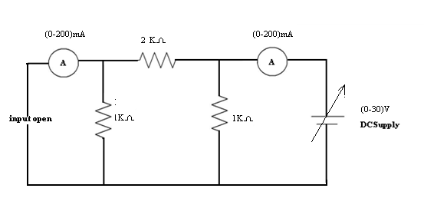

ABCD Parameters:

V₁ = AV₂ − BI₂

I₁ = CV₂ − DI₂

A = |  | V₁ |  |  |  |  |  |  |  | ; |  | C = |  |  | I₁
A = | V₂ |  |  |  |  |  |  |  |  |  |  |  | V₂
 |  |  |  |  |  |  | I₂ =0 |  |  |  |  |  |  |  |  |  |  |  |  |  | I₂ =0
B = − |  |  | V₁ |  |  |  |  |  |  |  |  | ; D |  | = − |  |  |  |  |  |  |  |  | I₁
 |  |  | I₂ |  |  |  |  |  |  | V =0 |  |  |  |  |  |  |  |  |  |  |  |  | I₂ |  |  |  |  |  |  | V =0
 |  |  |  |  |  |  |  |  |  | 2 |  |  |  |  |  |  |  |  |  |  |  |  |  |  |  |  | 2

Hybrid or h- Parameters:

V₁ = h₁₁I₁ + h₁₂V₂

I₂ = h₂₁I₁ + h₂₂V₂

^{h}11 | = | V₁ |  |  |  | ; | h₂₁ = |  | I ₂
^{h}11 | = | V₁ |  |  |  | ; | h₂₁ = |  | I₁
 |  | I₁ |  | V ₂ =0 |  |  |  |  | I₁ |  |  | V ₂ =0
^{h}12 | = | V₁ |  |  |  | ; | h₂₂ = |  | I ₂
^{h}12 | = | V₁ |  |  |  | ; | h₂₂ = | V ₂
 |  | V ₂ |  |  | I₁ =0 |  |  |  |  |  |  |  |  |  | I₁ =0

Procedure:

- Open circuiting input terminals (I₁ = 0):

  - Connections are made shown in fig (3).

  - Supply is given to output port.

  - The readings of ammeter as I₁ and Voltmeter as V₁ are noted down.

- Short circuiting input terminals (V₁=0):

  - Connections are made shown in fig (4).

  - Supply is given to output port.

  - The readings of ammeters as I₁& I₂ are noted down.

- The ABCD, Hybrid parameters are calculated using formulae and verified with theoretical values.

Observations:

When V₂=0

When I₁=0

S.No. | V1(V) | I ₂(A) | V₂(V)
When V₂=0

S.No. | V₁(V) | I ₁(A) | V₂(V)

When I₂=0

S.No. | V₁(V) | V₂(V) | I₁(A)

When V₂=0

S.No. | V1(V) | I₁(A) | I₂(A)

Result Table:

 |  | ABCD Parameters |  |  |  |  |  |  |  |  |  | Hybrid Parameters
 | A | B(Ω) |  | C(ᶷ) |  |  |  | D |  | h11(Ω) |  | h12 |  | h21 |  | h22(ᶷ)
Theoretical
Practical

Precautions:

- Making loose connections are to be avoided.

- Readings should be taken carefully without parallax error.

Result:

VIVA QUESTIONS :

- What are the equations of open circuit parameters?
- How can we obtain the short circuit parameters?
- What are transmission parameters?
- What are the equations of hybrid parameters?
- What is the condition for symmetry and condition for reciprocity in two port network parameters?
- Write Z-parameters in terms of hybrid parameters?
- Define port?
- What are the equation for hybrid parameters?
- What are the independent variables of ABCD parameters?
- Why impedence parameters are called as ope circuit parameters?
- Why Admittance parameters are called short circuit parameters?
- Give one real time application for all the four parameters?
- Mention dependent and independent variables for all parameters?
- Give the conditions for symmentry for z and h parameters?
- Convert z to y and y to h
- What are applications of ABCD parameters?
- Write the relations for ABCD parameters?
- Write the relationship ABCD and Z-parameters?
- What are applications of h-parameters?
- Write the relationship ABCD and h-parameters?

EXCERSISE PROBLEMS

1. To obtain experimentally H , parameters and of a given two port ∏ network
(R=4KΩ, 2KΩ, 2KΩ).
2. To obtain experimentally H, parameters and of a given two portT network
(R=1KΩ, 2KΩ, 2KΩ).
3. To obtain experimentally ABCD parameters and of a given two port T network
(R=2KΩ, 1KΩ, 2KΩ).
4. To obtain experimentally ABCD parameters and of a given two port ∏ network
(R=1KΩ, 2KΩ, 3KΩ).
5. To obtain experimentally H parameters and of a given two portT network
(R=3KΩ, 5KΩ, 6KΩ).
6. To obtain experimentally ABCD parameters and of a given two port ∏ network
(R=4KΩ, 8KΩ, 8KΩ).
7. To obtain experimentally Z, parameters and of a given two port∏ network
(R=3KΩ, 2KΩ, 2KΩ).
8. To obtain experimentally H parameters and of a given two port T Network
(R=4KΩ, 6KΩ, 7KΩ).
9. To obtain experimentally ABCD and H parameters and of a given two port∏ network
(R=4KΩ, 2KΩ, 2KΩ).
10. To obtain experimentally H parameters and of a given two port T network
(R=4KΩ, 12KΩ, 10KΩ).
11.To obtain experimentally H , parameters and of a given two port ∏ network
(R=2KΩ, 7KΩ, 3KΩ).
12. To obtain experimentally H, parameters and of a given two portT network
(R=2KΩ, 3KΩ, 5KΩ).
13. To obtain experimentally ABCD parameters and of a given two port T network
(R=2KΩ, 1KΩ, 2KΩ).
14. To obtain experimentally ABCD parameters and of a given two port ∏ network
(R=2KΩ, 2KΩ, 3KΩ).
15. To obtain experimentally H parameters and of a given two portT network
(R=3KΩ, 4KΩ, 6KΩ).
16. To obtain experimentally ABCD parameters and of a given two port ∏ network
(R=4KΩ, 6KΩ, 8KΩ).
17. To obtain experimentally Z, parameters and of a given two port∏ network
(R=2KΩ, 4KΩ, 2KΩ).
18. To obtain experimentally H parameters and of a given two port T Network
(R=2KΩ, 6KΩ, 7KΩ).
19. To obtain experimentally ABCD and H parameters and of a given two port∏ network
(R=2KΩ, 5KΩ, 2KΩ).
20. To obtain experimentally H parameters and of a given two port T network
(R=4KΩ, 12KΩ, 5KΩ).

Expt. No:8
Self & Mutual Induction Of A Coupled Circuit

AIM: Determination of self and mutual inductances of a coupled circuit to find the coupling co-efficient.
THEORY:
Self Inductance:
When a current is passed through a coil, then a magnetic flux is produced around it, now, if the direction of current is changed, then the direction of magnetic flux is also changed. If an alternating current is passed through the coil, then the magnetic field produced will also be alternating. In this way, An alternating magnetic flux produces an induced e.m.f in the coil.
“The property of a coil of inducing an e.m.f in itself when placed in an alternating magnetic field is known as self induction or self inductance. It is denoted by letter L. It s units is Henry which is denoted by letter H.
Mutual Inductance:
When two coils A and B are wound on the same core and an alternating current is passed through A, then an alternating magnetic flux is produced around the coiled A. But the coil B is also placed in the alternating magnetic flux of coil A, hence an e.m.f is induced in it which is called mutually induced emf and the property of the coils is called the mutual inductance. It is denoted by letter m. It units is henrys which is denoted by letter H.
Co-Efficient Of Coupling: The magnitude of the induced emf in the second coil depends on
the co-efficient of coupling between the two coil.
K= $\frac{M_{\text{12}}}{\sqrt{L_{1}L_{2}}}$, where M12 is the mutual inductance between two coils L1 and L2
are the self inductance of the two individual coils.
EXPERIMENT: The experiment is based on the inductive reactances of the series
connection as in fig.s shown below.

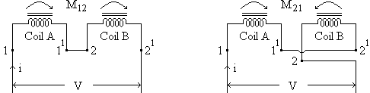
Fig.01 Series addition Fig.o2 Series opposition
With sinusoidal applied voltages, the coils excited individually the inductive reactances (which will be ωL₁ and ωL₂ at an angular frequency of ω) can be known.
Further the mutual inductance can be calculated as follows.
With the two coupled coils series connected as in fig.01 in terms of r.m.s. quantities, and considering and considering the coil resistances which are r₁ and r₂ for the two coils, we have
V = [(r₁+r₂) + jω(L₁+L₂+2M₁₂)] I
= [(r₁+r₂) + jX₁] I = Z₁I
With the two coils series connected in fig.02
V = [(r₁+r₂) + jω(L₁+L₂-2M₁₂)] I
= [(r₁+r₂) + jX₂] I = Z₂I
Then,
X₁- X₂ = ω[(L₁+L₂+2M₁₂) - (L₁+L₂-2M₁₂)]
= 4M₁₂ω
Also
Z₁- Z₂ = 4M₁₂ω
or
$M_{\text{12}}=\frac{X_{1}−X_{2}}{4ω}=\frac{Z_{1}−Z_{2}}{4ω}$
A single coil with a sinusoidal voltage offers a reactance given
$$V=\text{XI}=ω\text{LI}$$
$∴$ $L=\frac{V}{ωI}$
This equ. can be used to find out the inductive reactances of the individual coils. For the two coils A and B, thus the reactances ωL₁ and ωL₂ can be found, this is clearly under the assumption of negligible resistances of the coils. Knowing M₁₂, L₁ and L₂ the coupling co-efficient can be calculated using the relation
$K=\frac{M_{\text{12}}}{\sqrt{L_{1}L_{2}}}$
The coupling co-efficient, ‘K’ is unity when there is no leakage flux.
Then, $M_{\text{12}}=\sqrt{L_{1}L_{2}}$
In practice, however, leakage does exist and the coupling co-efficient is less than unity.
APPARATUS REQUIRED:
1. Coupled coil, 230v/40v ---------- ONE no.
2. Single phase variac, 0-270v, 10 amps ---------- ONE no.
3. Ammeter, 0-2.5/5 amp a.c. ---------- ONE no.
4. Voltmeter, 0-150/300 volts a.c. ---------- ONE no.

DETERMINATION OF SELF INDUCTANCE:
CIRCUIT DIAGRAM:
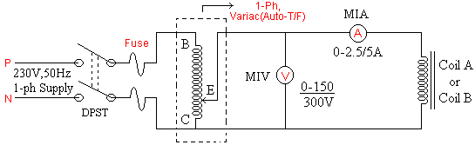
Experimental set up for determination of self inductance.
PROCEDURE:
1. Connect as shown in figure.
2. Set the variac output to zero, and switch ON the mains.
3. Increase the variac output to a suitable value to obtain a suitable current.
4. Note the readings of the voltmeter and ammeter.
5. Repeat the steps (3) and (4) above, to obtain more readings, at different voltages and currents.
6. Perform the experiment on the other coil also.
7. Measure the resistances of the both the coils by applying a low d.c. voltage and measuring the voltage and current.
8. Calculate the coil inductances using equ.V = XL = ωLI.

OBSERVATION TABLE:
 | Sl.No | Current  (Amps) | Voltage  (Volts) | $$Z=\frac{\text{Voltage}}{\text{Current}}$$ | $$X=\sqrt{Z^{2}−r^{2}}$$ | $$L=\frac{X}{ω}$$ | Remarks
Coil A | 1.  2.  3. |  |  |  |  |  | Inductance  of coil A
Coil B | 1.  2.  3. |  |  |  |  |  | Inductance  of coil B

DETERMINATION OF MUTUAL INDUCTANCE:
CIRCUIT DIAGRAM:
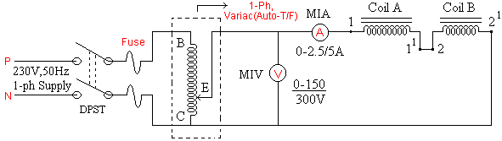
Experimental set up for determination of mutual inductance.
PROCEDURE:
1. Connect as shown in figure.
2. Set the variac output to zero, and switch ON the mains.
3. Adjust the variac output to a suitable value, so that a suitable current flows in the circuit.
4. Note the readings of the voltmeter and ammeter.
5. Repeat the steps (3) and (4) above for different suitable currents and the corresponding voltages.
6. Switch OFF the supply, setting the variac output to zero.
7. Reverse the connections of the coil B, it means join 1¹ to 2¹ and the end 2 will now be connected to the variac output.
8. Repeat the steps (3),(4) and (5) above, preferably with the same currents.
9. Calculate the mutual inductance using equ. $M_{\text{12}}=\frac{Z_{1}−Z_{2}}{4ω}$.
OBSERVATION TABLE:
Sl.No | Current  (Amps) | Voltage  (Volts) | $$Z_{1}=\frac{\text{Voltage}}{\text{Current}}$$ | Coil B reversed |  |  | $$M_{\text{12}}=\frac{Z_{1}−Z_{2}}{4ω}$$
 |  |  |  | Current  (Amps) | Voltage  (Volts) | $$Z_{2}=\frac{\text{Voltage}}{\text{Current}}$$ | $$M_{\text{12}}=\frac{Z_{1}−Z_{2}}{4ω}$$
1.
2.
3.
$∴$ $K=\frac{M_{\text{12}}}{\sqrt{L_{1}L_{2}}}$
Precautions:

- Making loose connections are to be avoided.

- Readings should be taken carefully without parallax error.

RESULTS:
Expt. No:9
Compensation And Milliman’s Theorem

AIM: Verification of compensation and Milliman’s theorem.
APPARATUS :

S.No | Name of the equipment | Range | Type | Quantity
1. | Ammeter | (0-200)mAmp | Digital | 1
2. | Voltmeter | (0-20)V | Digital | 1
3. | DC Power Supply | (0-30)V | Dual | 1
4. | Digital Multimeter | ------- | Digital | 2
5. | Connecting wires | ------- | ----- | as per need

THEORY: This theorem is particularly useful for the following two purposes.
- For analyzing those networks where the values of the branch elements are varied and studying the effect of tolerance on such values.
- For calculating the sensitivity of a bridge network.
As applied to D.C. Circuits it may be stated as if the resistance of any branch of a network is changed from R to (R+ΔR) where the current flowing originally is I, the change of current at any other place in the network may be calculated by assuming that an e.m.f of – IΔR has been injected into the modified branch while all other sources have their e.m.f suppressed and are represented by their internal resistances only.

CIRCUIT DIAGRAM:
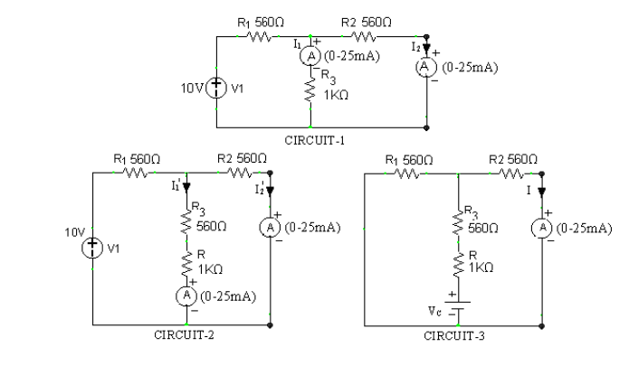Circuit diagram for verification of compensation theorem

PROCEDURE:
1. Make the connections as per the circuit diagram on to the bread board as shown in figure.
2. Apply the voltage of ------ volts DC, through an Regulated DC power supply to the circuit.
3. Find the original currents of all branches including load resistor R_{L} (specified branch) through an ammeter. Say $I_{1},I_{2}\text{.}\text{.}\text{.}I_{L}$.
4. Now, increase the load resistance to the value of R_{L}+ΔR_{L} and again find the changed currents flowing through the same branches as well as changed resistor (R_{L}+ΔR_{L}). Say $I_{1^{1}},I_{2^{1}}\text{.}\text{.}\text{.}I_{L^{1}}$.
5. Inject the source voltage i.e., V_{C} = -I_{L}R_{L} in series with the modified branch (load resistance = RL+ΔRL) while the other sources in the network being replaced by their internal resistances.
6. Now measure the compensating currents, Say $I_{1^{\text{11}}},I_{2^{\text{11}}}\text{.}\text{.}\text{.}I_{L^{\text{11}}}$which opposes the actual original currents which depends on flow of directions.
7. Compare these practical values with the theoretical values. Finally verify the theorem.

THEORETICAL CALCULATIONS:

OBSERVATION TABLE:

Step | Sl.No | Particulars | Theoretical values | Practical values
When  Load (R_{L})  = …. . . Ω,  V = ----- volts | 1.  2.  3. | I_{Total} (or) $I_{1}$  $$I_{2}$$  I_{Load} = $I_{L}$
When  Load (R_{L}+ ΔRL)  = …. . . Ω,  V = ----- volts | 1.  2.  3. | I_{Total} (or) $I_{1^{1}}$  $I_{2^{1}}$  I_{Load} = $I_{L^{1}}$
When  Load (R_{L}+ ΔRL)  = …. . . Ω,  V_{C} = ----- volts | 1.  2.  3. | I_{Total} (or) $I_{1^{\text{11}}}$  $$I_{2^{\text{11}}}$$  I_{Load} = $I_{L^{\text{11}}}$

Millman’s Theorem

Aim: Verification of Millman’s theorem.

Theory:
Millmann’s Theorem states that if ‘n’ voltage sources V₁, V₂ ------V_{n}, having internal
resistances, R₁, R₂ ------ R_{n} respectively, are in parallel as shown in figure (1) below then these sources may be replaced by a single voltage source V_{m} having internal resistance R_{m} is series as shown in fig(2). Where V_{m} and R_{m} given by the equations:

$V_{m}=\frac{V_{1}G_{1}+V_{2}G_{2}+−−−−V_{n}G_{n}}{G_{1}+G_{2}+−−−−G_{n}}$

$$R_{m}=\frac{1}{G_{1}+G_{2}+−−−−G_{n}}$$
Where G1, are conductances corresponding to R1, R2 ----Rn.
Circuit Diagram:
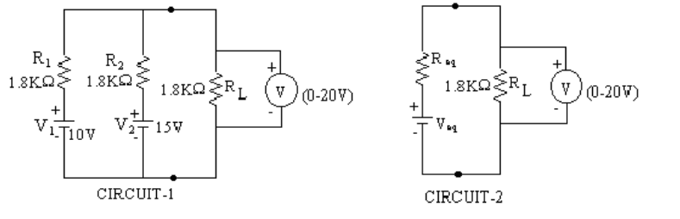
Experimental set up for verification of Millman’s theorem
Procedure:
1. Make the connections as per the circuit diagram on to the bread board as shown in fig. above.
2. Connect a DC ammeter in series with the load resistor R_{L.}
3. Apply the V₁ = ------- volts from CH-1, and V₂ = ------- volts from CH-2 to the circuit as shown.
4. Note the current passing through the load resistor R_{L} and tabulate it.
5. Compare the theoretical and practical values.

Theoretical Calculations:

Tabular Column:

 | Sl.No | Particulars | Theoretical values | Practical values
V₁ = ----- volts  V₂ = ----- volts  Load (R_{L})  = …. . . Ω | 1. | I_{LOAD}

Results:

Expt. No:10

Measurement Of Active Power For Star And Delta Connected Balanced Load

Aim: To measure the active power for the given star and delta network.

Apparatus:
S.No | Name of the equipment | Range | Type | Quantity
1. | Wattmeter | 0-10A/600V | MI | 2
2. | Rheostats | 0-200 ohms | Wire wound | 2
3. | Connecting wires | ------- | ----- | as per need

Theory:
A three phase balanced voltage is applied on a balanced three phase load when the current in each of the phase lags by an angle Φ behind corresponding phase voltages. Current through current coil of w1=Ir, current through current coil of W2=I B, while potential difference across voltage coil of W1=VRN-VYN=VRY(line voltage), and the potential difference across voltage coilof W2= VRN-VYN=VBY. Also , phase difference between IR and VRY is (300+Φ).While that between IB and VBY is (300-Φ).Thus reading on wattmeter W1 is given by W1=VRYIYCos(300+Φ) While reading on wattmeter W2 is given by
W2=VBYIBCos(300-Φ)Since the load is balanced,|IR|=|IY|=|IB|=I and
|VRY|=|VBY|=VLW1=VLICos(300+Φ)W2=VLICos(300-Φ).
Thus total power P is given byW= W1 +W2 = VLICos(300+Φ) +VLICos(300-Φ)= VLI[Cos(300+Φ) + Cos(300-Φ)]= [√3/2 *2CosΦ]VLI= √3VLICosΦ.

Circuit Diagram :

Star connected load:
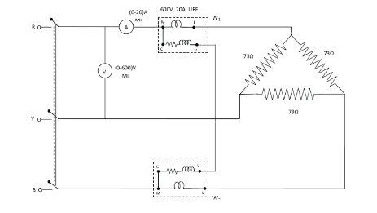
Delta connected load :
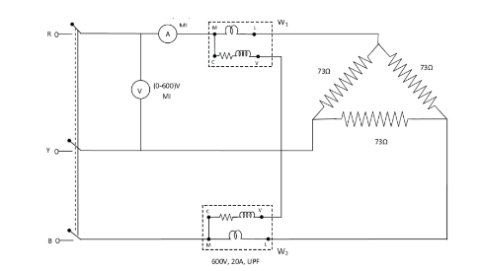
Procedure:
(Star connection):
1) Connect the circuit as shown in the figure.
2) Ammeter is connected in series with wattmeter whose other end is connected to one of the loads of the balanced loads.
3) The Y-phase is directly connected to one of the nodes of the 3-phsupply.
4) A wattmeter is connected across R-phase & Y-phase as shown in fig. The extreme of B phase is connected to the third terminal of the balanced 3-ph load.
5) Another wattmeter is connected across Y & B phase, the extreme of B-phase is connected to the third terminal of the balanced three phases load.
6) Verify the connections before switching on the 3-ph power supply.

(Delta connection):
1) Connect the circuit as shown in the figure.
2) Ammeter is connected in series with wattmeter whose other endis connected to one of the loads of the balanced loads.
3) The Y-phase is directly connected to one of the nodes of the 3-ph supply.
4) A wattmeter is connected across Y & B phase, the extreme of B-phase is connected to the third terminal of the balanced 3-ph load.
5) Another wattmeter is connected across R & Yphase, the extreme of R-phase is connected to the third terminal of the balanced three phases load.
6) Verify the connections before switching on the 3-ph power supply.
Precautions:
- Avoid making loose connections.

2. Readings should be taken carefully without parallax error.

Result:

Expt: 11
Measurement Of 3-Phase Reactive Power
Aim : To measure reactive power in a three-phase circuit using single phase wattmeter.

Apparatus :

Sl.No | Apparatus | Range | Type | Qty
1 | Voltmeter | (0-600V) | M I | 1 no.
2 | Wattmeter | 1φ,600V,10A, LPF | D.M.T | 1 no.
3 | Ammeter | 0-10A, | M I | 1 no.
4 | 3φ autotransformer | 415/0-470V,  10A, 8.14KVA |  | 1no.
5 | 3φ loading inductor | 10A, 415V |  | 1 no.

Precautions:
1. Ensure the minimum position of Three phase autotransformer during power on and off.
2. Set the ammeter pointer at zero position.
3. Take the readings without parallax error.
4. Avoid loose connections.

MODEL GRAPH:
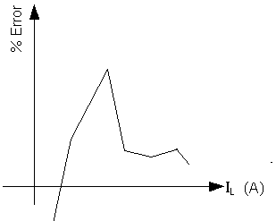

Procedure:
- Connect the circuit as per the circuit diagram.
- keep the variac of the auto-transformer in minimum position.
- Close supply TPST switch and vary the auto-transformer slowly and apply rated voltage i.e.230V.
- vary the load gradually and at different loads, note down readings of ammeter, Voltmeter and Wattmeter.
5. Draw the phasor diagram

CIRCUIT DIAGRAM:

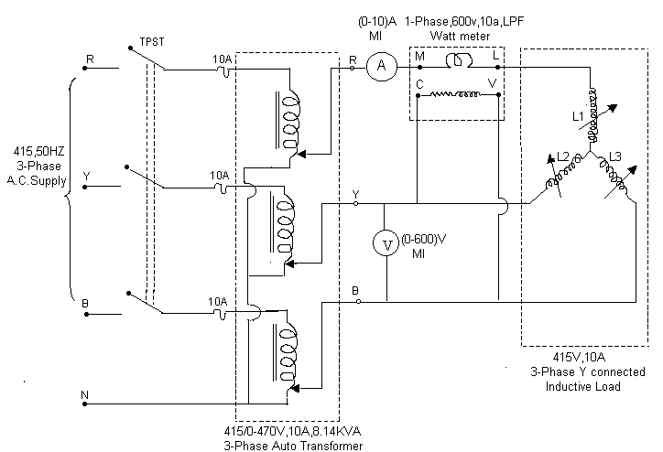

Theory:

Reactive power measurement in 3-φ circuits using 1-φ wattmeter can be done only for balanced 3-φ loads. By connecting the current coil of the wattmeter in one line and the pressure coil across the other two lines of 3-φ circuit, current through the current coil and voltage across the pressure coil are determined. Now as the current in the current coil lags the voltage by an angle of 90°,the wattmeter reads a value proportional to the reactive power of the circuit.

PHASOR Diagram:
I_{R}

V_{R}

V_{YB}
V_{BN}
V_{Y}

Tabular Column:

For ideal inductive load φ = 90⁰ --> Sinφ= 1
S.  No | Voltage  V_{L} volts | Current  I_{L} amp | Wattmeter reading (W) | Reactive power (measured value)Q_{m}=$\sqrt{3}W(\text{VAR})$ | Reactive power (actualvalue) Q_{a}=$\begin{aligned}\sqrt{3}V_{L}I_{L}\text{sin}φ \\ (\text{VAR})\end{aligned}$ | %error =  {(Q_{m}-Q_{a})/ Q_{a}}*100
1
2
3
4
5

SAMPLE CALCULATIONS:

Load voltage V_{L} =
Load current IL =
Watt meter reading W =
Reactive power (measured value) = $\sqrt{3}W$=
Reactive power (actual value) = $\sqrt{3}V_{L}I_{L}\text{sin}φ$=
% error = $\frac{\text{measured value - actual value}}{\text{actual value}}x\text{100}$

RESULT:

Viva Questions:-

1. What is meant by Reactive power?
2. What is the difference between balanced and unbalanced loads?

LAB ASSIGNMENT:
Calculate the active & apparent power for the given circuit

